Assignment 2
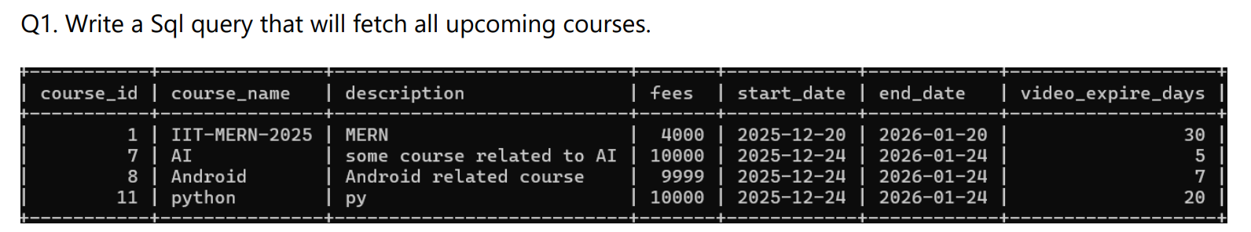
Query - select * from courses where start_date>curdate();
Output- 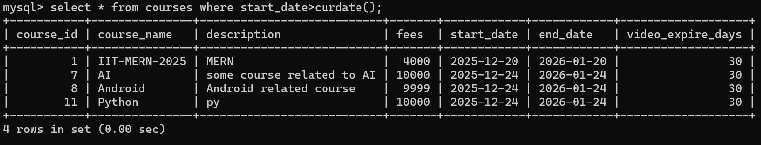
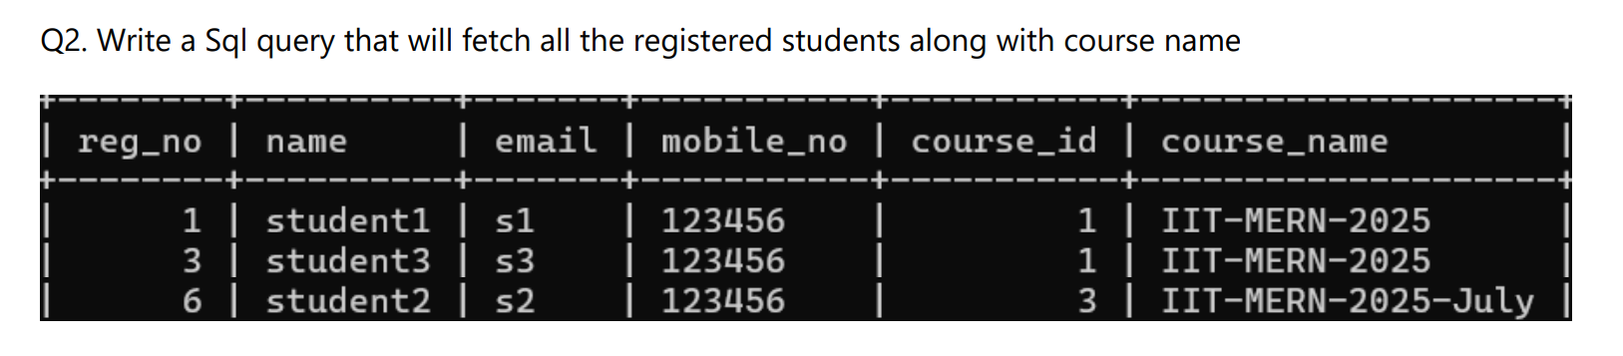
Query - select reg_no,name,email,mobile_no,s.course_id,c.course_name from students s join courses c on s.course_id = c.course_id;
Output- 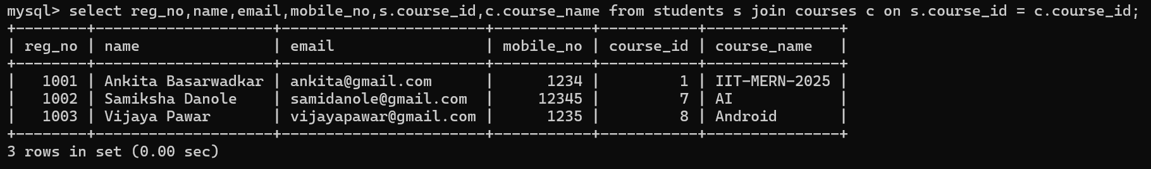

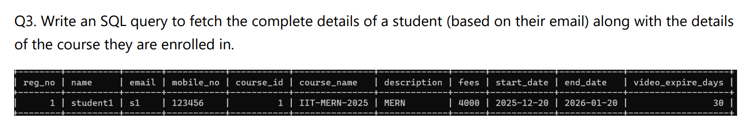
Query - select reg_no,name,email,mobile_no,s.course_id,course_name,description,fees,start_date,end_date,video_expire_days from Students s join courses c on s.course_id = c.course_id;
Output- 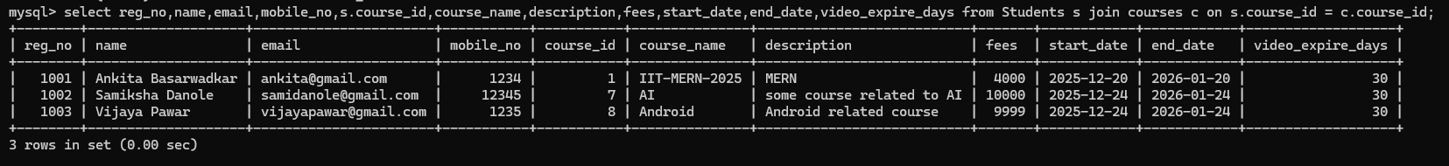
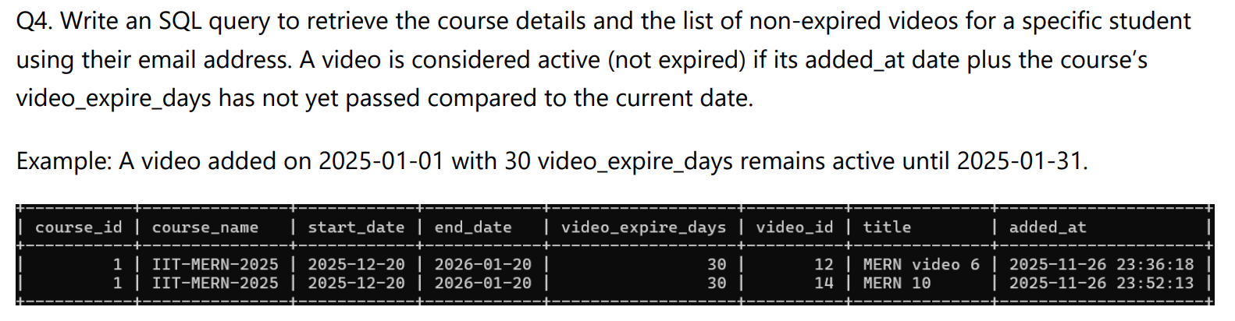
Query – select s.reg_no,s.name,s.email,c.course_id,c.course_name,v.video_id,v.title,v.added_date from students s join courses c on s.course_id = c.course_id join videos v on v.course_id = c.course_id where s.email='samidanole@gmail.com' and date_add(v.added_date,interval c.video_expire_days day) >= curdate();
Output-,
